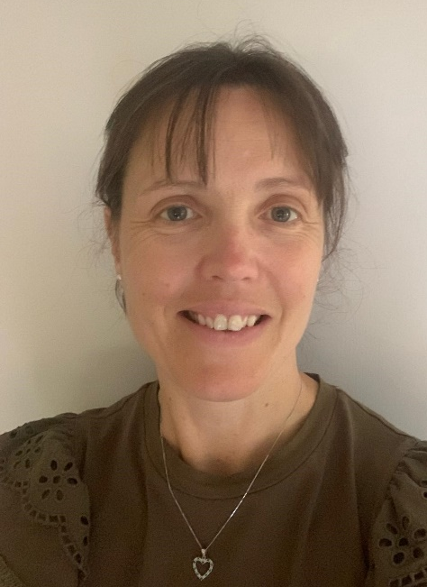

Vicki Purser
Forrest Medical Centre, Coventry
Aspiring Leader Fellow 2025/26 - Cohort 6
have worked as a 4 session GP Partner in Coventry for over 15 years. I am a trainer and until recently, worked as a Training Programme Director, helping deliver the AKT module, mentoring resident doctors and supporting local GP trainers. I am also Associate Dean for GP recruitment in the West Midlands and a GP Appraiser. I have a keen interest in education, recruitment and staff retention. Whilst recognising the excellent resident doctor retention rate locally, I understand the need for the wider primary care workforce to further evolve and would be interested in supporting local change.
One of my primary interests is in preventative health and lifestyle medicine. I frequently opt for non-medical interventions with patients, using opportunities to help support positive choices for the patient and their families. Working in an area of deprivation, I recognise the importance of not underestimating the financial and social pressures our patients are under, and the need for these interventions to be accessible and cheap or free. I firmly believe in the benefits of effective chronic disease care, having recently helped set up a more dynamic, proactive system for our patients. Another clinical interest I have is womens health medicine, particularly around contraception services (fitting coils and nexplanons) and HRT.
I recognise many of my interests are reflected in the 10 year plan, and am excited by the opportunities which may become available to primary care, focusing on more population, proactive, preventative healthcare. I hope the 10 year plan will attract funding to reflect this change in workload.
The Aspiring Leaders Fellowship offers a fantastic opportunity for me to work collaboratively with new networks and understand wider system working and decision making. I hope to utilise this opportunity to explore opportunities for the next stage of my career development. I am keen to develop my leadership skills and understand myself more as a leader. I look forward to gaining experience and seeking opportunities to further comprehend how we can achieve a better valued primary care, which is sustainable and fit for purpose.

