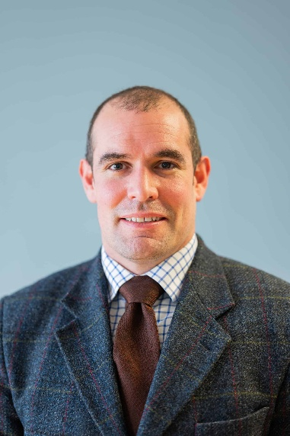
Ed Baker
Primary Care, Coventry and Warwickshire ICS
Aspiring Leader Fellow 2025/26 - Cohort 6

My name is Ed Baker, I work in Primary Care as a First Contact Practitioner Physiotherapist, with over 15 years of clinical experience in Primary Care and interface services. My expertise spans MSK clinical specialties, advanced practice, first contact practice, and strategic planning for MSK services.
Currently, I also contribute to the Coventry and Warwickshire Training Hub, supporting FCP Physiotherapists, Advanced Practitioners, and Podiatrists working in Primary Care. Additionally, I serve as the Get It Right First Time (GIRFT) Midland’s lead for Community MSK pathways.
I am deeply passionate about supporting Allied Health Professionals (AHPs) because I believe they hold immense potential to transform healthcare delivery in Primary Care. Having witnessed firsthand the positive impact skilled AHPs can have on patient outcomes and service efficiency, I am driven to nurture their development both clinically and strategically. Supporting AHPs enables me to contribute to a more sustainable, patient-centered healthcare system where multidisciplinary teams thrive.
Beyond this, I am interested in leadership roles that foster innovation, collaboration, and the empowerment of clinical teams. I aim to cultivate leadership skills that will allow me to influence service design and delivery positively and advocate for AHPs at a strategic level.
Through the ALF course, I hope to develop my leadership capabilities further—gaining new insights, tools, and networks that will enable me to lead transformational change with confidence and purpose. Personally, I want to grow as a leader who not only drives service improvement but also inspires and supports others to realize their full potential within Primary Care.

