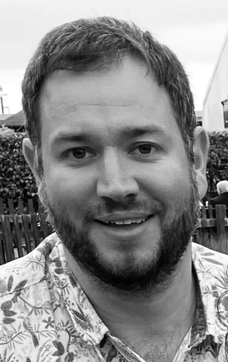

Dave Pearce
Revel Surgery, Brinklow
Aspiring Leader Fellow 2025/26 - Cohort 6

I’m Dave and I’m a 6-session GP in the Rugby PCN, also doing 2 sessions a week for a private telemedicine company. I first came to Warwickshire as a fresh faced 18-year-old to do a Biochemistry degree, and apart from an adventure doing A+E in Australia for a year I have been here ever since.
I love being a GP and working in a small team where we collaboratively work towards the best outcomes for our patients. I enjoy the variety and the range of skills I have had to develop during more than a decade of general practice.
I applied for the fellowship because I am keen for a new challenge and to expand my skills and experience beyond the consulting room. I have aim to get involved in projects that change outcomes at a higher level to both improve systems and ultimately patient care. My specialist areas of interest include dermatoscopy and joint injections, but am very keen to be involved in any projects that improve the lives of the population we serve.

