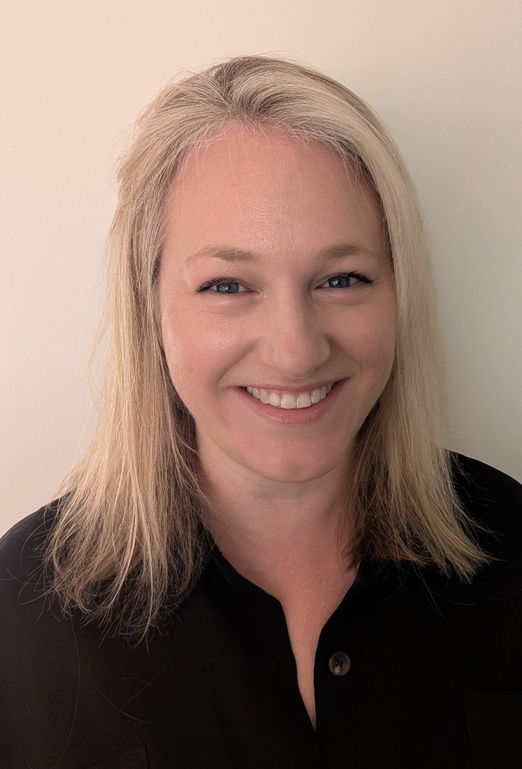
Abbie Martin
Southam Surgery, Southam
Aspiring Leader Fellow 2025/26 - Cohort 6

I’m Abbie, a 5 session GP partner at Southam Surgery. I completed my graduate entry medical degree from Warwick Medical School in 2008 and completed my GP VTS training in Coventry and Warwickshire in 2016. Prior to obtaining my medical degree, I gained experience in the private healthcare sector and pharmaceutical industry.

I enjoy a varied role as a GP and medical student trainer, safeguarding & palliative care lead and PCN collaboration. A large part of my partnership work has been to respond to wider system changes and to develop, implement and review processes and protocols to deliver improved, cost-effective and sustainable patient care. More widely, I have previously helped to inform and develop better safeguarding practices through work with the then CCG and Ardens.

My interest lies in transformation and workforce strategy, particularly in developing, improving and delivering efficient processes to support both clinicians and patients. Being a GP partner gives me a great perspective which I will draw on to help bring change and support local NHS services.

