Social Prescribing Link Worker Training and Supervision
What is a Social Prescribing Link Worker (SPLW)?
Social prescribing is a way to connect people with community-based services, groups and activities that meet practical, social, and emotional needs that affect their health and wellbeing.
Training requirements (for SPLWs employed in or by PCNs)
• An induction and onboarding. See the NHSE England SPLW welcome pack.
• The mandatory HEE e-learning programme and the PCI e-learning training expectations including core skill modules.
•Additional training within PCN’s or training hubs https://www.cwtraininghub.co.uk/
• Attendance & protected learning time at peer support networks delivered at place or system by the ICS and/or NHS England in the region.
• Digital systems supporting SPLW (SPLW digital platforms providers) e.g. FutureNHS Social Prescribing Collaboration Platform
• Evidence in practice of reaching SPLW Competencies as stated within Social Prescribing Link Worker Workforce Development framework Annex A – SPLW competency framework
Supervision requirements
• The PCN must appoint a GP supervisor to provide direct supervision for the SPLW.
• Monthly clinical supervision with a relevant health professional. This may be the GP supervisor or other suitably qualified health professional.
• A first point of contact for general advice and support for the SPLW for each GP practice they work in.
• Access to educational supervision to support development of Portfolio of Evidence.
The contractual obligations relating to support for SPLW’s are set out in the Network Contract DES contract documentation, and the supervision requirements are detailed at Social Prescribing Link Worker Workforce Development framework
Competency Framework
• The Competency Framework sets out the competencies that all SPLWs require to be effective and assists those who employ or direct the activities of SPLWs to understand how these competencies can be achieved. This is aligned to the Core Curriculum for Personalised Care published by the Personalised Care Institute (PCI).
• The framework can be used with the Portfolio of Evidence to enable supervisors and SPLWs to explore their skills and development needs.

Care Coordinator Training and Supervision
What is a Care Coordinator?
Care coordinators (CC’s) identify and work with people, including the frail/elderly and those with long-term conditions, to provide coordination and navigation of care and support across health and care services. They take a personalised approach and bring together all the information about a person’s care and support needs, playing a key role in personalised care and support planning and focus on the six components of personalised care.
Training requirements (for care coordinators employed in or by PCNs)
• An induction and onboarding. See the NHSE England Care Coordinator welcome pack
• Personalised Care 2-day accredited training by Personalised Care Institute (PCI) LINK
• The mandatory HEE e-learning programme and the PCI e-learning training expectations including Core skills modules, Personalised Care Support Planning and Shared Decision Making.
• Attendance & protected learning time at peer support networks delivered at place or system by the ICS and/or NHS England in the region.
•Additional training within PCN’s or training hubs https://www.cwtraininghub.co.uk/ including: Electronic health systems & patient data ; Induction to MDT working; Health inequalities; Cohort specific training e.g. learning disabilities, diabetes, frailty.
• Digital systems supporting CC’s (CC digital platforms providers) e.g. FutureNHS Care coordinator collaboration and community of practice platform
• Evidence in practice of reaching CC Competencies as stated within Workforce development framework for care coordinators
Supervision requirements
• The PCN must appoint a GP supervisor to provide direct supervision for the CC.
• Monthly clinical supervision with a relevant health professional. This may be the GP supervisor or other suitably qualified health professional.
• A first point of contact for general advice and support for the CC for each GP practice they work in.
• Access to educational supervision to support development of Portfolio of Evidence.
The contractual obligations relating to support for CC’s are set out in the Network Contract DES contract documentation, and the supervision requirements are detailed at Workforce development framework for care coordinators
Competency Framework
The Competency framework for care coordinators sets out the competencies that all CC’s require to be effective and assists those who employ or direct the activities of CC’s to understand how these competencies can be achieved. It is aligned to Core Curriculum for Personalised Care published by the Personalised Care Institute (PCI).

Health & Wellbeing Coach Training and Supervision
What is a Health & Wellbeing Coach?
Health and Wellbeing Coaches (HWBC’s) use health coaching skills to support people to develop the knowledge, skills, and confidence to become active participants in their care so that they can reach their own health and wellbeing goals. Utilising behaviour change approaches, goal setting and coaching conversations and tools to empower, engage and increase motivation within individuals.
Training requirements (for Health & Wellbeing Coaches employed in or by PCNs)
• An induction and onboarding. See the NHSE England Health & Wellbeing welcome pack
• 4 day Health and Wellbeing Coach Training accredited by The Personalised Care Institute (PCI) LINK
• The mandatory HEE e-learning programme and the PCI e-learning training expectations including Core skills modules, Personalised Care Support Planning and Shared Decision Making.
• Attendance & protected learning time at peer support networks delivered at place or system by the ICS and/or NHS England in the region.
•Additional training within PCN’s or training hubs https://www.cwtraininghub.co.uk/ including: Electronic health systems & patient data; Induction to MDT working; Health inequalities; Cohort specific training e.g. learning disabilities, diabetes, frailty.
• Digital systems supporting HWBC’s (HWBC digital platforms providers) e.g. FutureNHS HWBC collaboration and community of practice platform.
• Evidence in practice of reaching HWBC competencies as stated within Workforce development framework for Health & Wellbeing Coaches
Supervision requirements
• The PCN must appoint a GP supervisor to provide direct supervision for the HWBC.
• A first point of contact for general advice and support for the HWBC for each GP practice they work in.
• Three types of supervision are required: clinical supervision, line management/supervision and coaching supervision from a qualified coaching supervisor.
• Monthly clinical supervision with a relevant health professional. This may be the GP supervisor or other suitably qualified health professional.
• Access to educational supervision to support CPD & development of Portfolio of Evidence.
The contractual obligations relating to support for HWBC’s are set out in the Network Contract DES contract documentation, and the supervision requirements are detailed at Workforce development framework for Health & Wellbeing Coaches

Competency Framework
• There are four tiers of practice/expertise for health and wellbeing coaches reflective of different career stages.
• The Competency Framework for Health & Wellbeing Coaches sets out the competencies that all HWBC’s require to be effective and assists those who employ or direct the activities of HWBC’s to understand how these competencies can be achieved. It is aligned to Core Curriculum for Personalised Care published by the Personalised Care Institute (PCI).
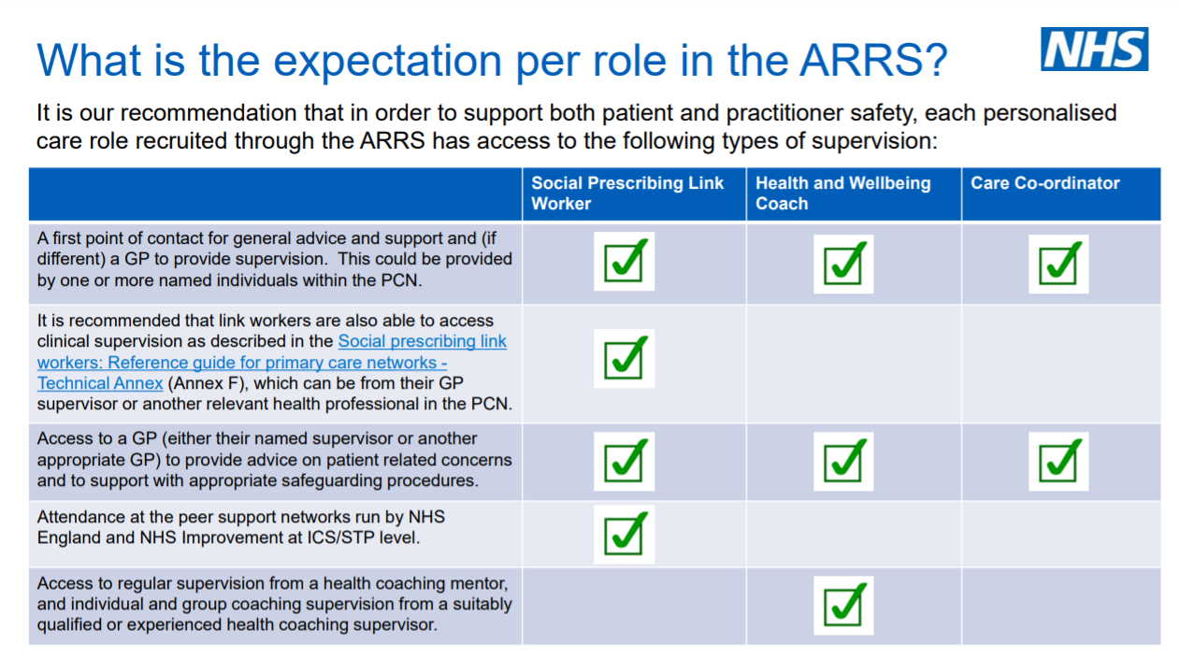

What is the expectation per role in the ARRS?
Note. Adapted from: Supervision for roles recruited through the Additional Roles Reimbursement Scheme (ARRS) (p.6). NHS England, NHS Improvement (2020). LINK
See Social Prescribing Link Worker Workforce Development framework; Workforce Development Framework for Care Coordinators; Workforce Development Framework for Health & Wellbeing coaches and Additional Roles Quick Reference Summary for further information.

