A qualitative exploration of inequalities on access to community diagnostics

CDC Inequalities Research

Information for Health Professionals

Research overview
C&W ICB have commissioned Coventry University to conduct the research, as an independent partner. Coventry University will work in partnership with Healthwatch Coventry, Healthwatch Warwickshire and EQuIP to facilitate conversations with underserved communities.
This research aims to increase our understanding of the barriers faced by local population groups in accessing diagnostic services, and to explore how these can be overcome such that these populations feel better supported to access necessary diagnostic tests in a timely manner.

Aims and objectives of the research
- To conduct focus groups and interviews with healthcare providers to identify local communities with the highest perceived inequalities in accessing diagnostic services.
- To conduct narrative interviews with members of underserved communities to identify the barriers faced by local population groups in accessing diagnostic services.
- To work with underserved communities to develop recommendations for addressing inequalities in accessing diagnostic services.
- To work with healthcare providers to develop a plan for effective implementation of recommendations to address inequalities in accessing diagnostic services.

Research Structure
The research has been structured into three distinct work packages:
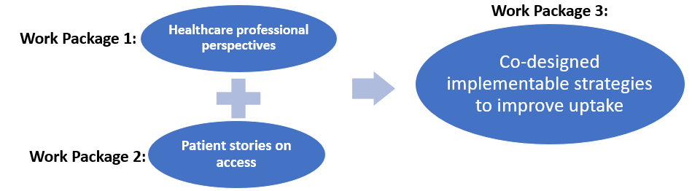

Get involved!
This research aims to gather perspectives from health care professionals, clinical and operational, and patients. Below is more information for health professionals interested in getting involved:

Health professional perspectives – work package 1
You will be asked to discuss topics such as:
- which patient groups participants you commonly interact with
- what you perceive are local inequalities
- which patient groups you feel frequently encounter barriers in accessing diagnostics
- in what diagnostic areas these barriers are most encountered
Commitment: A one-to-one interview, conducted remotely, with a member of the research team lasting 30 to 40 minutes (currently planned to take place between June and August)

Co-design strategies - work package 3
You will be asked to work with other professionals and patients to co-design solutions to the priority barriers that are raised. Depending on your professional role, you may also be in a position to support to implementation of these solutions at a local level.
Commitment: Participation in a group session, conducted remotely, lasting approximately 2 hours (dates to be confirmed, sessions to run November/December)

If you would like more information about this research or would like to participate, please contact:
Dr Eleanor Lutman-White (she/her), Research Fellow, Coventry University
Email: eleanor.lutman-white@coventry.ac.uk
Mobile: 07392 097010

