Since April 2021, University Hospitals Coventry and Warwickshire has provided the First Contact Practitioner (FCP) Musculoskeletal service to seven Primary Care Networks across Coventry. The FCP service was initially delivered within 37 GP practices covering 56 sessions per week and has since expanded to 68 sessions per week. The FCP service allows direct access for patients with musculoskeletal complaints to be seen in Primary Care by a specialist physiotherapist, who is skilled and experienced in the assessment, diagnosis, and management of musculoskeletal conditions. The role offers additional expertise in Primary Care to manage musculoskeletal conditions whilst releasing capacity for General Practitioners and improving access for service users. By employing experienced Physiotherapists, we have been able to ensure that patients get access to the right clinician, in the right place, at the right time.
Data concerning the service processes and clinical outcomes have been evaluated since inception to ensure UHCW is providing an efficient and clinically effective service. Since inception, UHCW FCP service has delivered more than 20,000 appointments for Primary Care in Coventry. The results are summarised in the infographic below.
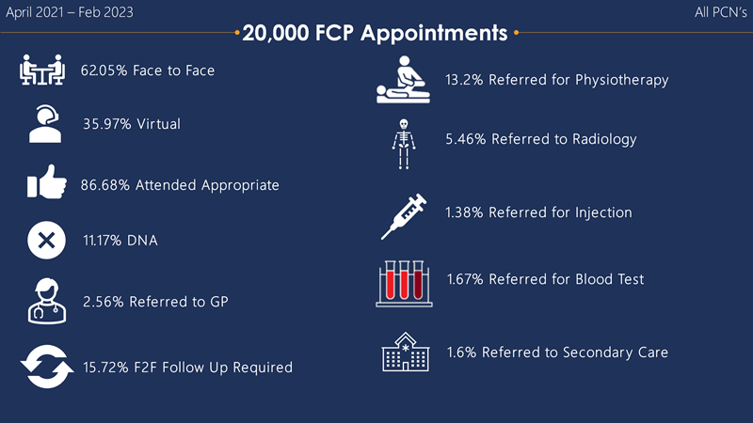
The data demonstrates the impact of the UHCW FCP service for people with musculoskeletal disorders in Coventry. To highlight, very few patients (2.56%; n=512) have required a follow-up appointment with their GP, meaning that our FCPs have been able to release over 19,488 appointments in Primary Care. Only 13.2% (n=2,640) of the contacts were referred to Physiotherapy, meaning that our FCP service has been able to direct at least 16,848 patients towards self-management advice or to a more appropriate service. In addition, 5.46% (n=1,120) of people were referred for diagnostic imaging. Lastly, 1.6 % (n=320) referrals were made to secondary care services (Neurosurgery, Rheumatology, Orthopaedics, Pain Clinic) ensuring we are only referring appropriate patients into Secondary Care, promoting self-management and care within the community.
Overall, UHCW FCP service has achieved its ambitions of being a clinically effective and efficient service. For the future, we will continue to drive improvements and invest in our staff to ensure we continue to provide high quality care for all.

